Detailed Report on

Seminar-cum-Cultural Festival during the

Second Sanchar Mahotsav 2024

Submitted to

Ministry of culture,

CFPG Programme,

Govt. of India,New Delhi
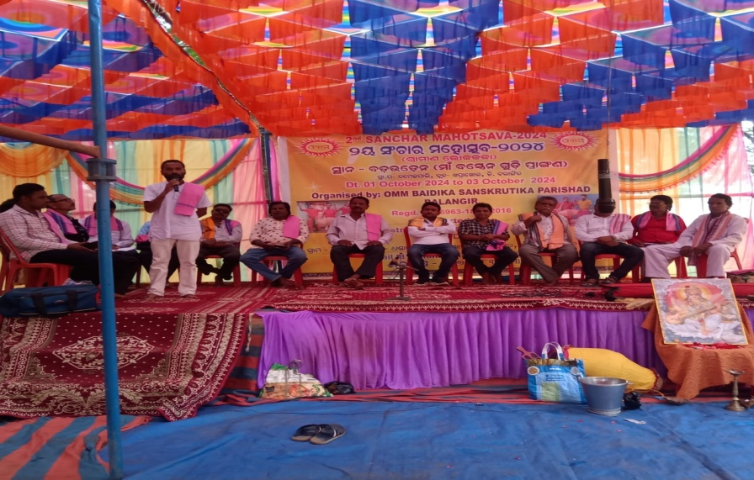

Submitted by:

OMM BAIDIKA SANSSKRUTIKA PARISAD

At- Malpada, Po- Dhandamunda, Ps- Khaprakhol, Dist-Balangir, Odisha

Supported by: Ministry of Culture, Govt. of India, New Delhi

Introduction to the Cultural Background of Western Odisha Folk Dance: A Focus on Balangir, Bargarh, and Nuapada Districts
Western Odisha, known for its rich cultural diversity, has a deeply rooted tradition of folk dances that embody the region's unique heritage and way of life. The districts of Balangir, Bargarh, and Nuapada stand out for their vibrant folk dance forms, which have been passed down through generations, reflecting the collective emotions, spirituality, and socio-cultural identity of the people. These folk dances are not merely art forms but are deeply interwoven with the lives of the people, often performed during festivals, harvest celebrations, religious rituals, and communal gatherings.One of the most prominent dance forms of this region, Sambalpuri Dance, originated in the broader Sambalpur area but is widely performed in Balangir, Bargarh, and Nuapada. This dance is closely tied to the agrarian lifestyle of the people, and it is an integral part of festivals like Nuakhai, a harvest festival that celebrates the new crop. Performed to the rhythm of traditional instruments like dhol, nishan, tasa, and mahuri, Sambalpuri dance captures the rural vigor and joy of the people.The dancers, dressed in vibrant traditional costumes, move with energetic steps, swaying to the lively beats of the drums, reflecting the unity and harmony of village life. The Paschim Odisha folk songs, accompanying the dance, speak of love, devotion, and the beauty of nature.The Dalkhai Dance is another popular folk dance form, especially in Balangir and Bargarh. Performed by women, this dance is a key feature during festivals like Dussehra and Nuakhai, where young girls and women, adorned in traditional Sambalpuri sarees, dance in circular formations while singing Dalkhai songs. The lyrics are often infused with themes of love, nature, and mythological tales, while the accompanying men beat on drums and other instruments, creating a dynamic interplay of sound and movement.The dance’s elegance lies in its synchronization and the lively, quick-footed movements of the dancers, which symbolize the grace and energy of the youth in rural Odisha. Dalkhai songs, with their rhythmic beats, form an inseparable part of the dance, making it an exhilarating experience for both performers and spectators. The Karma Dance, primarily performed in Nuapada and parts of Balangir, is associated with the worship of the Karma deity, believed to bring prosperity and good fortune. It is performed during the Karma festival, a tribal festival celebrated by the Adivasi and non-Adivasi communities. The dance is symbolic of gratitude toward nature and the belief in a good harvest.During the Karma festival, men and women form a circle around the sacred Karam tree and dance to the rhythmic beats of drums and cymbals. The dance steps are simple but graceful, emphasizing a deep connection to nature, community, and spirituality.Rasarkeli and Jaiphula are traditional folk dances of western Odisha, performed during weddings and other social gatherings. Particularly popular in Bargarh and Balangir, these dance forms reflect the social customs and joyous occasions in rural life. Rasarkeli, known for its playful and flirtatious movements, is often performed by young men and women, symbolizing love and courtship.The songs accompanying these dances are poetic, often centered on romantic themes, nature, and seasonal changes. The graceful movements and the playful interaction between the dancers reflect the simplicity and warmth of rural life. Although primarily associated with the Kalahandi region, the Ghumura Dance has found prominence in Nuapada and neighboring districts. This dance, performed during festivals and victory celebrations, is marked by the use of the ghumura, a traditional drum, and the dance itself carries mythological significance, symbolizing valor and celebration. It is often compared to war dances due to its energetic and martial movements, with dancers dressed in warrior-like costumes.

Cultural Significance and Modern Adaptations:
Folk dances in the districts of Balangir, Bargarh, and Nuapada are a celebration of life, nature, and spirituality. They have been instrumental in preserving the cultural identity of the people, acting as a medium of storytelling, social commentary, and religious devotion. Each dance form, be it Sambalpuri, Dalkhai, or Karma, carries a deep sense of community bonding and continuity of tradition.
With changing times, there have been efforts to modernize and adapt these traditional forms. While keeping their essence intact, some folk dances are now performed on bigger platforms such as state and national festivals, giving them exposure and recognition beyond rural borders. Government and cultural organizations, including the Odisha Sangeet Natak Academy and the Ministry of Culture, have played a pivotal role in promoting these dance forms, ensuring that they remain a vital part of Odisha’s cultural landscape.
FEW WORDS ABOUT OBSP-
OMM BAIDIK SANSKRUTIKA PARISAD(OBSP), Malpada, Khaprakhol, Dist- Balangir, Odisha is a leading Non-Govt. Organization having Regd. No-6963-2016 of 2016 under Societies Regd. Act-1860; Dist- Balangir is working for development and rejuvenation of traditional Cultural Local folklores since its inception. On this behalf organization organized a special programme to renovate with sustainable development of Sanchar Lok Kala ( a traditional folklore of this region of western Odisha) through organizing its annual meet of traditional cultural troupes through a single platform i.e. Sanchar Mahotsava-2024 in collaboration with Ministry of Culture, Govt of India from 1st October 2024 (Tuesday) to 3rd October 2024 (Thursday) at Bastren gudi premises of Village Baduden Po- Damaipali, Ps- Khaprakhol, Balangir Odisha.

Introduction to the Sanchar2024:
The Second Sanchar Mahotsav 2024, a grand event celebrating the rich heritage of Baidik culture, was successfully organized by OMM Baidik Sanskrutika Parisad, Malpada, Khaprakhol from 1st October 2024 to 3rd October 2024. The event was graciously supported by the Ministry of Culture, Government of India, New Delhi. The three-day long event witnessed a seamless blend of intellectual discussions, cultural showcases, and community engagement activities, aimed at reviving and preserving the values of our ancient Baidik traditions.
Held at Maa Bastren Gudi Premises, Baduden, Khaprakhol in Balangir District, Odisha, the Mahotsav attracted a large gathering from across the state, including scholars, spiritual leaders, artists, and cultural enthusiasts.

Day 1: 1st October 2024
Programme AGENDA;
Inaugural Ceremony: As per the Programme an Inaugural ceremony Scheduled on Dt-01/10/2024 Tuesday on an average time of 10 am- Gathering of Guests from different part of the district as well as from nearby district i.e. Balangir, Bargarh, Nuapada etc.with their cultural teams were took participate in this programme. With an opening patriotic song from the Artists from OBSP, The Mahotsav began with an auspicious inaugural ceremony at 9:00 AM, presided over by dignitaries including prominent Baidik scholars, local political leaders, and representatives from the Ministry of Culture. The ceremony commenced with the traditional lighting of the lamp, invoking blessings from the Almighty, followed by a soulful rendition of the Baidik mantras, symbolizing peace and prosperity.
The Chief Guest, Sj. Sudam Bishi President ZKSS, Balangir and Chief Speaker Smt. Nirupama Patel, Chairman, Khaprakhol Block lighting the Candle with the presence of other Honorable guests named;
- Smt. Tarakanti Tandi Sarapancha, Damaipali GP., Khaprakhol Block,Balangir, Odisha
- Sj. Pabitra Patel Social Activist, Dhandamunda,Khaprakhol,Balangir , Odisha
- Sj. Minaketan Padhan, Chief Organiser, Jibanyash Sangathan, Laxmimunda, Patnagarh,Odisha
- Sj. Osta Barge Sanchar Guru,Jhiniki Dunguri Patnagarh, Balangir,Odisha.
- Sj. Binod Bihari Das, President, Bande Utkal Kalakar Sangha Balangir, Odisha.
- Sj. Madhusudan Sahu Social Activist, Matiabhata, Khaprakhol, Balangir, Odisha.
- Sj. Kapurchan Chhatria, President, Lingaraj Sanskrutika Parisad, Chhaliamal, Belpada, Balangir, Odisha.
- Sj. Haribola Podh,Ex. Vice President BKSS,Khaprakhol, Balangir, Odisha.
- Sj. Saroj Mishra, Reporter Sambad Odia Daily News paper, Khaprakhol, Balangir, Odisha.
Prima-facie, at 10.30 am-Brief descriptions on the programme has been explained by Sj. Thabir Charan Sahu, Secretary, Omm Baidik Sanskrutik Parisad, with detailed three days work scheduled for the participants on this occasion of Sanchar Mahotsava. He also focused on the renovation of this culture from this region of the Odisha to make it popular among each part of the state. Then as per the schedule the Sj Binod Bihari Das Chair the meeting as president with his some dedicative messages among the participants. Keynote speakers highlighted the importance of preserving India’s rich cultural heritage, with special emphasis on the ancient Baidik traditions. The Chief Guest, Shri Sudam Bishi President ZKSS delivered an inspiring speech on the role of culture in shaping society and the significance of such festivals in promoting unity and spiritual consciousness. Then Chief Speaker speaks about the present scenario of Primitive Sanchar in this region of western Odisha, with giving some of clues of its sustainability. He also emphasized on both the pros and cons of this cultural troupes found in this region. In between this discussion the veteran artist Sj. Osta Barge, Sanchar Guru, Patnagarh reminded the previous mode of performance of Sanchar Lok Kala without adequate Light and Sound, even he explained the poverty of artists at that time. He also focused to encouragement of this cultural activity. Then honorable guest Pabitra Putel explain the history of this culture with some of chanting on Lord Laxmi Vishnu and also focused the respect and honor ship towards Girls and Women with his suitable voice. Likewise other participants also gave their personal feelings and suggestions regarding cultural sustainability of this Sanchar Lok Kala.

Seminar on Lok Kala Sanchar as per the western Odisha Baidik Traditions:
The seminar focused on the theme "Relevance of Baidik Culture in Contemporary Society." Eminent scholars and speakers shared insights into the philosophical, spiritual, and social dimensions of Baidik literature and practices. Some key presentations included:
- "The Timeless Wisdom of the Lokkala" by Sanchar Guru Oste Barge, who discussed the universality and modern-day relevance of Vedic teachings.
- "Sanchar Rituals: Pathways to Spiritual Enlightenment" by Shri Binod Bihari Das a renowned spiritual leader, who elaborated on how these rituals foster inner peace and societal harmony.
The seminar also included interactive sessions where participants engaged in discussions with the speakers, making the event intellectually stimulating and educational.

Day 2: 2nd October 2024

Cultural Performances:
Day 2 was dedicated to cultural expressions that highlighted the diversity and beauty of India’s Lokkala traditions. The day began with a traditional dance recital depicting ancient stories from the Sanchar, performed by a talented local dance troupe. This was followed by various cultural performances, including:
- Traditional music performances (Spiritua Sanchar chants set to music)
- Folk dances from the region of Odisha, showcasing the seamless integration of spirituality and culture.
- Drama performances based on Sanchar Baidik mythology, such as enactments of stories from the Upanishads and the Ramayana, which enthralled the audience.
These performances were designed to inspire the younger generation and encourage them to explore the profound cultural heritage that defines our identity.. Most of prominent Troupes participated in this celebration are;
- Sri Chaitanya Sanchar Dala, Dudumdarha, Khaprakhol.
- Sri Gouranga Sanchar Dal, Talbhata , Belpada
- Sri Nitai Sanchar Dal, Anakamara,Khaprakhol
- Maa Bindhyabasini Karma Dal,Anakamara, Khaprakhol.
- Maa Bastren Karma Dal, Baduden, Khaprakhol.
- Sri Jagannath Sankirtan Dal, Damaipali, Khaprakhol.
- Krushna Guru Bhajan Dal, Turla, Khaprakhol
- Maa Bindhyabasini Sambalpuri Dance Troup, Matiabhata.
- Maa Bastren Sankirtan Dal, Baduden.
- Bhima Bhoi Khanjani Dal, Matiabhata.
- Amhima Alekh Khanjani Dal , Pacher, Khaprakhol.
- Nitai Gouranga Sanchar Dal, Matiabhata, Khaprakhol.

Exhibition:
An exhibition showcasing ancient Baidik manuscripts, artifacts, and literature was also organized. The exhibition was curetted with the aim of educating the visitors about the historical significance and the enduring value of traditional culture teachings. There were dedicated stalls for handicrafts and traditional art forms, promoting local artisans and their work. The response from the attendees, especially students and youth, was highly positive, with many expressing newfound interest in Vedic culture.

Day 3: 3rd October 2024

Workshop on Baidik Rituals and Practices:
On the final day, a workshop was organized to give the attendees hands-on experience with Sanchar rituals. Led by prominent dignitaries and Baidik scholars, the workshop provided practical insights into the daily rituals, meditation practices, and chants that are integral to the Baidik way of life. The attendees learned about the significance of each ritual and how to incorporate these practices into their daily lives for spiritual upliftment.

Panel Discussion:
The concluding seminar of the festival featured a panel discussion on the topic "The Role of Cultural Festivals in Nation Building." Distinguished panelists from various fields—education, arts, spirituality, and governance—shared their views on how festivals like the Sanchar Mahotsav play a pivotal role in preserving cultural identity and fostering national unity.
The panelists emphasized that cultural festivals are not merely entertainment but are vital in reconnecting people with their roots, thereby building a strong and resilient society. The discussion received enthusiastic participation from the audience, who raised pertinent questions about the challenges of preserving culture in modern times.

Valedictory Ceremony:
The Mahotsav concluded with a grand valedictory ceremony, during which all participants were honored for their contributions. The Chief Guest, Shri Sj. Sudam Bishi praised the efforts of OMM Baidik Sanskrutika Parisad and the Ministry of Culture for their dedication to promoting India's spiritual and cultural legacy. Awards were presented to artists, scholars, and volunteers who had contributed to the success of the event.
In his closing remarks, the President of OMM Baidik Sanskrutika Parisad expressed heartfelt gratitude to the Ministry of Culture for their unwavering support and to all the participants, volunteers, and the audience for making the Second Sanchar Mahotsav 2024 a resounding success.

Conclusion:
The folk dances of Western Odisha, especially in Balangir, Bargarh, and Nuapada, are a testament to the region's deep cultural roots and rich traditions. These dances not only entertain but also convey the collective identity, beliefs, and values of the communities. They serve as a living reminder of the importance of preserving cultural heritage while adapting to the modern world. Through their vibrant music, colorful attire, and synchronized movements, these folk dances continue to inspire pride and joy in the hearts of the people of Odisha.
The Second Sanchar Mahotsav 2024 was a remarkable event that not only celebrated Baidik traditions but also succeeded in bringing together people from diverse backgrounds to rediscover the spiritual and cultural wealth of India. The three-day event provided an enriching experience through its blend of intellectual discourses, cultural performances, and community engagement activities.
With the support of the Ministry of Culture, Government of India, the Mahotsav reaffirmed the importance of cultural festivals in strengthening societal bonds and preserving our ancient traditions for future generations. It is hoped that the success of this event will encourage more such festivals in the years to come, further fostering the spirit of cultural unity and national pride.
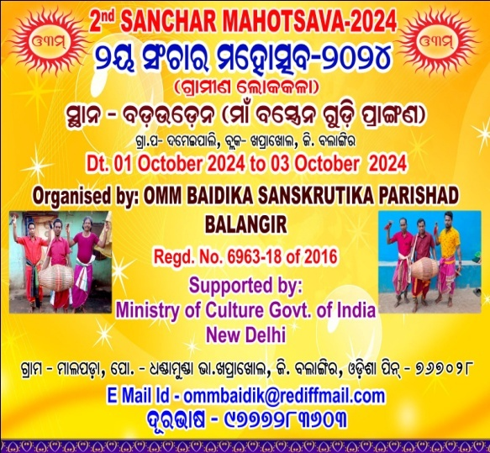
PROGRAMME PHOTO CLIPS
